



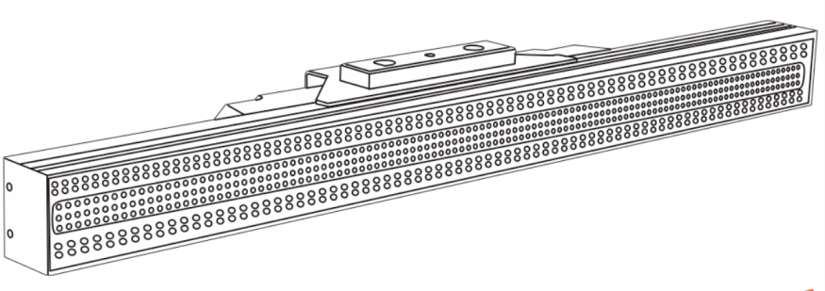

User Manual

Table of Contents

- Safety Instructions........................................................01
- Technical specifications...............................................03
- Control panel.................................................................03
- Initial Setup……….........................................................04
- Dimensions....................................................................06
- DMX settings..................................................................06
- Fixture Information........................................................07
- DMX Control…...............................................................08
- Maintenance...................................................................12

1. Safety Instructions

Please read the user manual carefully prior to operating the fixture or connecting to power.

Please keep this user manual for future reference. All persons operating this fixture are required to read this manual prior to use.

1. Unpack the unit from its packaging and make sure there is no physical damage present from the shipping process.

2. Before operating, ensure that the voltage and frequency of power supply match the power requirements of the unit.

3. It is important to connect the power to an outlet that has proper ground in order to avoid electric shock.

4. This fixture is for indoor use only. Use only in a dry locations.

5. The unit must be installed in a location with adequate ventilation, at least 50cm from adjacent surfaces. Be sure that no ventilation slots are blocked.

6. Disconnect main power cable prior to moving or servicing the fixture.

7. Make sure there are no flammable materials close to the unit while operating, as it will create a fire hazard.

8. Use a safety cables when mounting this unit above floor height.

9. Maximum ambient temperature is Ta: 40 degrees C. DO NOT operate it where the temperature is higher than max temperature rating.

10. Unit surface temperature may reach up to 75 degrees C. DO NOT touch the housing with bare‐hands during its operation. Turn off the power and allow the fixture to cool for about 15 minutes prior to handling.

11. In the event of an issue operating the fixture properly, stop using the unit immediately. Never try to repair the unit by yourself. There are no user serviceable parts in this fixture. Repairs carried out by unauthorized technicians can lead to further damage or malfunction to the fixture and user.

12. Please contact the nearest authorized service center for all repairs. Always use the same type spare parts.

13. DO NOT touch any of the wires during operation as high voltage may cause electric shock.

01
Warning:
1. To prevent or reduce the risk of electrical shock or fire, do not expose the unit to rain or moisture.
2.The housing and lenses must be replaced if they are visibly damaged.

Caution:
There are no user serviceable parts inside the unit. Do not open the housing or attempt any repairs by yourself. In the unlikely event your unit may require service, please contact the nearest authorized dealer or service center.

Installation:
The fixture should be mounted via its Omega Quick Release Clamp bracket. Always ensure that the unit is firmly fixed to avoid vibration and slipping while operating. Make sure that the structure to which you are attaching the unit is secure and is able to support a weight of 10 times that of the fixtures weight. Always use a safety cable that can hold 10 times that of the weight of the fixture when installing.

*INSTALLATION OF THE EQUIPMENT MUST BE DONE BY QUALIFIED INDIVIDUALS*

02
2. Technical Specifications

Light source：384pcs high brightness white LEDs，384pcs RGB LEDs
Max power (flashing mode)：480W
Max power consumption (continuous lighting)：250W
Life time：50,000 Hours
Beam angle（white）：65 degree
Beam angle（RGB）：50 degree
Dimmer：0-100% electronic linear dimming
Strobe：0-30Hz/sec
Control mode：DMX512/Master/slave/Auto run/Manual
Channel：6CH/17CH/256CH/268CH
White color has 64 segments for auto run effects.
Each RGB has 64 segments individual controlled
Housing：Black IP rating：IP20
Dimensions：923*175*120mm
Weight：6.2kg

3. Control Panel

1. Display：Shows the various menus and selected functions
2. Button：
MODE | To select the programming of functions
Enter | To go forward the selected functions
UP | To the previous functions
DOWN | To the next functions
3. Mains in：Powercon connection from main power supply
4. DMX in & out：DMX512 link

03
4. Initial Setup

To select any of the given functions, press the MUSE button until the required function is showing on the display. Select the function by pressing the ENTER button again and the display will blink. Use the DOWN/UP buttons to change the mode. Once the required mode has been selected, press the ENTER button to setup, to go back to the functions without any change press the MUSE button.
Menu
 | Programming | Menu item | Description
 | DMX Address | A001-A512
 | Fade Time | Speed | Speed (000-007)
 | Dimmer Curve | Mode | Curve（0-3）
 | Info | Test1
 | Info | Version | V05.11
 | Info | Reset | NO/Yes
 | Info | Test2
 | Temp | Temp1 | XXX℃
 | Temp | Temp2 | XXX℃

04
Menu
 | Back L | 60s
 | Back L | On
 | Back L | 300s
 | Back L | 120s
 | Manual | Dimmer (000-255)
 | Manual | White (000-255)
 | Manual | Blue（000-255）
 | Manual | Green（000-255）
 | Manual | Red（000-255）
 | Manual | Strobe（000-255）
 | Masmode | No
 | Masmode | Yes
 | Effect On Auto | Dimmer(000-255)
 | Effect On Auto | Strobe(000-255)
 | Auto | Auto(00-36)
 | DMX Monitor | DMX CH:01-06/CH:01-17  CH:01-256/CH01-268
 | Channel | 6CH/17CH/256CH/268CH

05
5. Dimensions

910.0
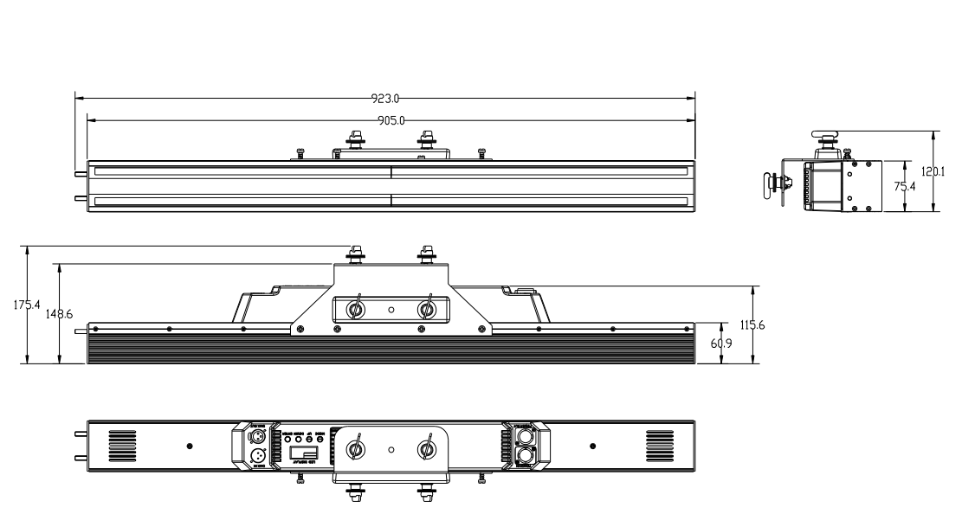
895.0

6. DMX setting

DMX addressing
To select DMX Address, press the MODE button to show the DMX ADDRESS on the display. Use the UP/DOWN button to adjust the address from 001 to 512, press the button to setup. Press the MODE button back to the last menu or let the unit idle one minute to exit menu mode.

DMX Channel Mode
To select DMX Channel Mode, press the ENTER button to show the DMX CHANNEL MODE on the display. Use the UP/DOWN button to select different channels, and press the ENTER button to setup. Press the MODE button back to the last menu or let the unit idle one minute to exit menu mode.

DMX Functions
Enter MODE mode, select DMX Functions, press the ENTER button to confirm, use the UP/DOWN button to select DMX Address, DMX Channel Mode or View DMX Value.

06

7. Fixture Information
Enter the MUSE system information, press the button to confirm, and use the up / down button to select: usage time, led usage hours, temperature, fan status, firmware version or error information。

8. DMX Control
1. If you are using a controller with 5 pins DMX output, you need to use a 5 to 3 pin adapter cable.
2. The last units DMX cable has to be terminated with a 120 ohm 1/4W resistor between pin 2(DMX-) and pin 3(DMX+) of a 3-pin XLR plug and plug it in the DMX output of the last unit.
3. Connect the unit together in a `daisy chain` by XLR plug from the output of the unit to the input of the next unit. The cable can not branched or split to a `Y` cable. DMX 512 is a very high-speed signal. Inadequate or damaged cables, soldered joints or corroded connectors can easily distort the signal and shut down the system.
4. The DMX output and input connectors are pass-through to maintain the DMX circuit, when one of the units’ power is disconnected.
5. Each fixture unit needs to have an address set to receive the data sent by the controller. The address number is between 1-512.
6. The end of the DMX 512 system should be terminated to reduce signal errors.
7. 3 pin XLR connectors are more popular than 5 pin XLR.
3 pin XLR: Pin 1: GND, Pin 2: Negative signal (-), Pin 3: Positive signal (+)
5 pin XLR: Pin 1: GND, Pin 2: Negative signal (-), Pin 3: Positive signal (+),
Pin 4/Pin 5: Not used.

DMX Chart
268 CH mode
268 CH | Function | Value | Description
1 | Dimmer | 000- 255 0%~ 100% | From dark to bright
2 | Duration (White) | 000- 255 0%~ 100% | From dark to bright
3 | Frequency( white) | 000- 255 0%~ 100% | From slow to fast
4 | Flashing effect (W) | 000- 255 0%~ 100% | Effect changing
5 | Flashing (RGB) | 000- 255 0%~ 100% | From slow to fast
6 | Running effect (W) | 000- 255 0%~ 100% | Effect changing
7 | Speed (W) | 000- 255 0%~ 100% | From slow to fast
8 | Running effect(RGB) | 000- 255 0%~ 100% | Effect changing
9 | Speed(RGB) | 000- 255 0%~ 100% | From slow to fast
10 | RGB macro | 000- 255 0%~ 100% | Color changing
11 | Backlight(RGB fade) | 000- 255 0%~ 100% | RGB auto run back light
12 | Direction | 000- 255 0%~ 100% | From R to L→From L to R
13 | Red 1 | 000- 255 0%~ 100% | From dark to bright
14 | Greed 1 | 000- 255 0%~ 100% | From dark to bright
15 | Blue 1 | 000- 255 0%~ 100% | From dark to bright
16 | Red 2 | 000- 255 0%~ 100% | From dark to bright
17 | Green 2 | 000- 255 0%~ 100% | From dark to bright
18 | Blue 2 | 000- 255 0%~ 100% | From dark to bright
19 | Red 3 | 000- 255 0%~ 100% | From dark to bright
20 | Green 3 | 000- 255 0%~ 100% | From dark to bright
21 | Blue 3 | 000- 255 0%~ 100% | From dark to bright
..... | ......... | ............................ | .........
202 | Red 64 | 000- 255 0%~ 100% | From dark to bright
203 | Green 64 | 000- 255 0%~ 100% | From dark to bright
204 | Blue 64 | 000- 255 0%~ 100% | From dark to bright
205 | White 1 | 000- 255 0%~ 100% | From dark to bright
206 | White 2 | 000- 255 0%~ 100% | From dark to bright

..... | ......... | ............................ | .........
268 | White 64 | 000- 255 0%~ 100% | From dark to bright

256 CH mode
256 CH | Function | Value | Description
1 | Red 1 | 000- 255 0%~ 100% | From dark to bright
2 | Green 1 | 000- 255 0%~ 100% | From dark to bright
3 | Blue 1 | 000- 255 0%~ 100% | From dark to bright
4 | Red 2 | 000- 255 0%~ 100% | From dark to bright
5 | Green 2 | 000- 255 0%~ 100% | From dark to bright
6 | Blue 2 | 000- 255 0%~ 100% | From dark to bright
7 | Red 3 | 000- 255 0%~ 100% | From dark to bright
8 | Green 3 | 000- 255 0%~ 100% | From dark to bright
9 | Blue 3 | 000- 255 0%~ 100% | From dark to bright
10 | Red 4 | 000- 255 0%~ 100% | From dark to bright
11 | Green 4 | 000- 255 0%~ 100% | From dark to bright
12 | Blue 4 | 000- 255 0%~ 100% | From dark to bright
13 | Red 5 | 000- 255 0%~ 100% | From dark to bright
14 | Green 5 | 000- 255 0%~ 100% | From dark to bright
15 | Blue 5 | 000- 255 0%~ 100% | From dark to bright
..... | ......... | ............................ | From dark to bright
190 | Red 64 | 000- 255 0%~ 100% | From dark to bright
191 | Green 64 | 000- 255 0%~ 100% | From dark to bright
192 | Blue 64 | 000- 255 0%~ 100% | From dark to bright
193 | White 1 | 000- 255 0%~ 100% | From dark to bright
194 | White 2 | 000- 255 0%~ 100% | From dark to bright
195 | White 3 | 000- 255 0%~ 100% | From dark to bright
196 | White 4 | 000- 255 0%~ 100% | From dark to bright
197 | White 5 | 000- 255 0%~ 100% | From dark to bright
198 | White 6 | 000- 255 0%~ 100% | From dark to bright
..... | ......... | ............................ | From dark to bright
255 | White 63 | 000- 255 0%~ 100% | From dark to bright
256 | White 64 | 000- 255 0%~ 100% | From dark to bright

17 CH

17CH | Function | Value | Description
1 | Master dimmer | 000- 255 0%~ 100% | From dark to bright
2 | Yellow | 000- 255 0%~ 100% | From dark to bright
3 | Red | 000- 255 0%~ 100% | From dark to bright
4 | Green | 000- 255 0%~ 100% | From dark to bright
5 | Blue | 000- 255 0%~ 100% | From dark to bright
6 | White | 000- 255 0%~ 100% | From dark to bright
7 | Flashing duration(W) | 000- 255 0%~ 100% | From dark to bright
8 | Frequency | 000- 255 0%~ 100% | From slow to fast
9 | Flashing effect(W) | 000- 255 0%~ 100% | Effect changing
10 | Flashing(RGB) | 000- 255 0%~ 100% | From slow to fast
11 | Running effect(W) | 000- 255 0%~ 100% | Effect changing
12 | Speed(W) | 000- 255 0%~ 100% | From slow to fast
13 | Running effect (RGB) | 000- 255 0%~ 100% | Effect changing
14 | Speed (RGB) | 000- 255 0%~ 100% | From slow to fast
15 | RGB macro | 000- 255 0%~ 100% | Color changing
16 | Backlight (RBG) | 000- 255 0%~ 100% | backlight
17 | Direction | 000- 255 0%~ 100% | From R to L→From L to R

6 CH mode
6CH | Function | Value | Description
1 | Strobe | 000- 255 0%~ 100% | From slow to fast
2 | Master dimmer | 000- 255 0%~ 100% | From dark to bright
3 | Red | 000- 255 0%~ 100% | From dark to bright
4 | Green | 000- 255 0%~ 100% | From dark to bright
5 | Blue | 000- 255 0%~ 100% | From dark to bright
6 | White | 000- 255 0%~ 100% | From dark to bright

09

9. Maintenance
Following are a few common problems that may occur during operation. Here
are some suggestions for easy troubleshooting:

A. The unit does not work, no light and the fan does not work
1. Check the connection of power and main fuse.
2. Measure the mains voltage on the main connector.
3. Check the power on LED.

B. Not responding to DMX controller
1. DMX LED should be on. If not, check DMX connectors and cables to see if link properly.
2. If the DMX LED is on and no response to the channel, check the address settings and DMX polarity.
3. If you have intermittent DMX signal problems, check the pins on connectors or on PCB of the unit or the previous one.
4. Try to use another DMX controller.
5. Check if the DMX cables run near or run alongside to high voltage cables that may cause damage or interference to DMX interface circuit.

C. One of the channels is not working well
1. The stepper motor might be damaged or the cable connected to the PCB is broken.

10．Factory reset
Address | 001
Channel | 17 CH
Curve | 000
Fade Time | 000



