

200W LED WW/CW Fresnel with Zoom
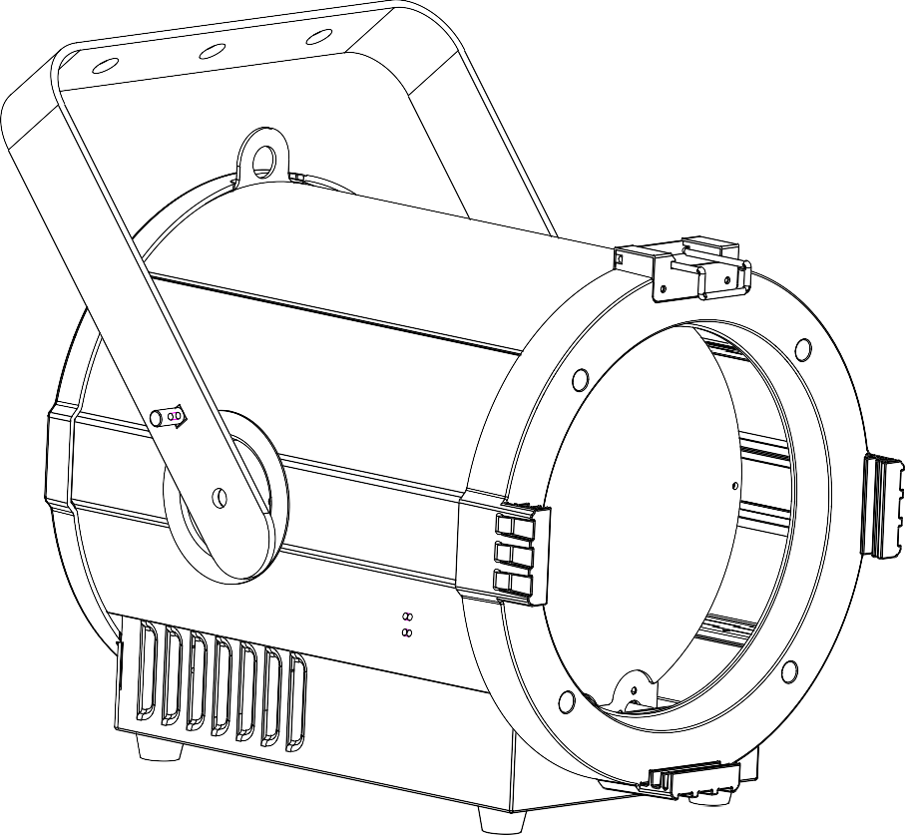

USER MANUAL


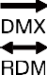

Caution!

CAUTION: Make sure fixture is properly plugged in and grounded to avoid electrical shock.
Avoid looking directly into the light source from close distances!
Wear protective glasses and other PPE (personal protective equipment) when working on or near the fixture.
Always make sure you are connecting this product to the proper voltage in accordance with the specifications in this manual or on the product’s specification label.
DO NOT open housing while fixture is powered on, even if the light source is off. Unplug power cable before opening the housing! Make sure that the power cord is never crimped or damaged by sharp edges. Check the fixture and the power cord from time to time do avoid electrical shock to user or damage to fixture. Make sure to replace the fuse with another of the same type and rating.

For your own safety, please read this user manual carefully before your initial start-up.
Follow operating safety precautions and pay attention to warning sign methods and equipment in this user manual.
Warning! This symbol indicates a hot surface. Certain parts of the housing can become hot during operation. After use, wait for a cool-down period of at least 10 minutes before handling or transporting the device.
Indoor use only! To prevent risk of fire or shock, do not expose this product to rain or moisture. IP 20 rating.
The ambient temperature must always be between -5° C and +45° C.

All persons involved with the installation, operation, and maintenance of this device have to
- Be qualified
- Follow the instructions of this manual
- Consider this manual to be part of the total product
- Keep this manual for the entire service life of the product
- Pass this manual on to every user of the product
- Download the latest version of the user manual from manufacturers website

Introduction
Thank you for having chosen the Studio FR2. You will see you acquired a powerful and versatile fixture for use in both studio and stage. Before your initial start-up, please make sure that there is no damage caused by transportation or shipping. Should there be any damages present please consult your dealer and do not use the device.

Safety instructions
This fixture has left our factory in absolutely perfect condition. In order to maintain this condition and to ensure safe operation, it is absolutely necessary for the user to follow the safety instructions and warning notes written in this user manual. Always disconnect power prior to performing cleaning or any maintenance. There are no user serviceable parts inside the device. Maintenance and service operations are only to be carried out by authorized dealers or service technicians authorized by Acue Lighting, Inc. in order to avoid voiding your warranty.

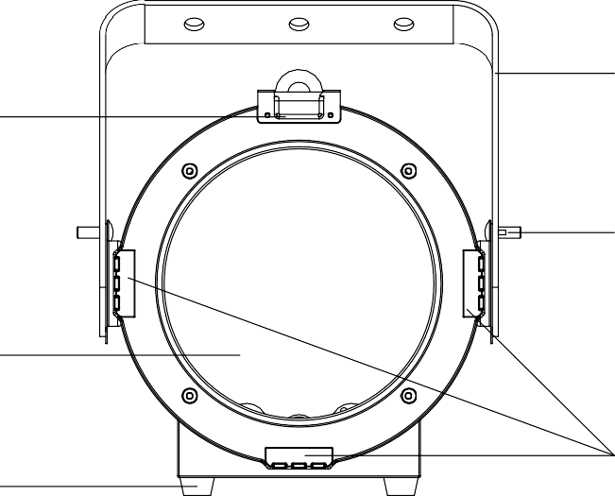
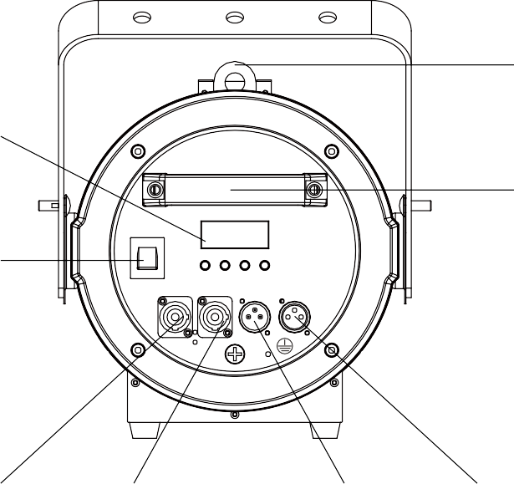
Overview

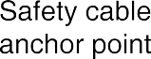
Installation

**SAFETY INFORMATION**
This fixture is designed for indoor use only and must be used in a dry location with adequate ventilation. Ensure that none of the fixture’s ventilation slots are blocked.

Fasten the fixture to a secure structure or surface. Do not stand fixture on a surface or leave it where it can be moved or fall over. If you install the fixture in a location where it may cause injury or damage if it falls, make sure secure it as directed in this user manual using a securely anchored safety cable that will hold the fixture if the primary fastening method fails.

Fastening the fixture to a flat surface
The fixture can be fastened to a hard, fixed, flat surface that is oriented at any angle. Ensure that the surface and all fasteners used can support at least 10 times the weight of all fixtures and equipment to be installed on it.
Fasten the fixture securely. Do not stand it on a surface or leave it where it can be moved or fall over.
If you install the fixture in a location where it may cause injury or damage if it falls, secure it as directed below with a securely anchored safety cable that will hold the fixture if the primary fastening method fails.

Mounting the fixture on a truss
The fixture can be clamped to a truss or similar rigging structure in any orientation. When installing the fixture hanging vertically down, you can use an open-type clamp such as a C-clamp or trigger clamp. When installing in any other orientation, you must use a half-coupler clamp that completely encircles the truss tube.

To clamp the fixture to a truss:
- Check that the rigging structure can support at least 10 times the weight of all fixtures and equipment to be installed on it.
- Block access under the work area.
- Fold the legs of the mounting bracket together and bolt a rigging clamp securely to the mounting bracket. The bolt used must be M10, grade 8.8 steel at the minimum. It must pass through both mounting bracket legs and be fastened with a self-locking nut.
- Working from a stable platform, hang the fixture with its clamp on the truss and fasten the clamp securely.
- Secure the fixture with a safety cable as directed below.

Securing with a safety cable
Secure the fixture with a safety cable (or other secondary attachment) that is approved for the weight of the fixture so that the safety cable will hold the fixture if the primary attachment point fails.

Loop the safety cable through the eyebolt in the back of the fixture and around a secure anchoring point. Do not loop the safety cable around the fixture’s mounting bracket only, as this will leave the fixture unsecured if it separates from the bracket.

DMX-512 connection/connection between fixtures

Description of the XLR-connection:

DMX OUT DMX IN

  - Ground
  - Signal (-)
  - Signal (+)
- Ground
- Signal (-)
- Signal (+)

If you are using a controller for operation, you can connect the DMX-output of the controller directly to the DMX-input of the first fixture in the DMX-chain. If you wish to connect multiple fixtures to the same chain you may do so using the DMX output of the fixture.

Building a serial DMX-chain:
Connect the DMX-output of the first fixture in the DMX-chain with the DMX-input of the next fixture. Always connect one output with the input of the next fixture until all fixtures are connected.

DMX-512 connection with DMX terminator:
For installations where the DMX cable has to run a long distance or is in an electrically noisy environment, such as in a club or studio, it is recommended to use a DMX terminator. This helps in preventing interference of the digital control signal by electrical noise. The DMX terminator is simply an XLR plug with

a 120 ohm resistor connected between pins 2 and 3, which is then plugged into the DMX output socket of the last fixture in the chain.

Caution: For the last fixture in the chain, the DMX-cable has to be terminated with a DMX terminator. Solder a 120 resistor between Signal (–) and Signal (+) into a 3-pin XLR-plug and plug it in the DMX-output of the last fixture.

Power connection

Power Requirements
The Studio FR2 zoom luminaire operates on 100 to 240 volts AC (+/- 10%, auto-ranging). This luminaire contains an auto-switching power supply.

Power linking between fixtures:
The fixture has built in powercon in and out sockets. Connect the power out to the power in socket of the next fixture in the chain until all fixtures are connected.
Caution: maximum power linking - 6 units.

Connection with the mains:
Connect the device to the mains with the enclosed powercon cable.

The description of the powercon cable layout are as below:

Cable color | Connection | International
Brown/Black | Live | L
Blue/White | Neutral | N
Yellow/Green | Earth(Ground) | 

Operation
The Studio FR2 zoom can operate in different modes. In each mode you can run the fixture as a stand-alone fixture or in a master/slave configuration. This next section will detail the differences in the operating modes.

Control Menu Map
MENU | SUB MENU | OPERATION
Addr | d001-d512 | RDM/DMX address
CHnL | 2CH | Channel mode
CHnL | 3CH | Channel mode
CHnL | 4CH | Channel mode
CHnL | 5CH | Channel mode
Strb | S.01-s.20 | Strobe with speed increasing
uL-- | u.000-u.255 | Dimmer
FL-- | F.000-255 | Zoom function
nodE | nod.0 | Dimmer speed 0 (no delay)
nodE | nod.1 | Dimmer speed 1
nodE | nod.2 | Dimmer speed 2
nodE | nod.3 | Dimmer speed 3
nodE | nod.4 | Dimmer speed 4 (slowest speed)
Id | Id.01-Id.66 | ID address setting

MENU | SUB MENU | OPERATION
tEnP | -25~100 | Fixture temperature
UErn |  | Firmware version
rSEt | yes/no | Reset
pnnF | (1.2~24.0)F | PWM refresh rate adjustment(KHz)

Addressing
All fixtures should be given a DMX address when using DMX signal, so that the correct fixture responds to the correct control signal. This digital starting address is the channel number from which t he fixture starts to listen to the digital control information sent out from the DMX controller. The allocation of this starting address is achieved by setting the correct number on the display located on the base of the device.

You can set the same starting address for all fixtures or a group of fixtures, or make different address for each fixture individually.

If you set the same address, all the units will start to listen to the same control signal from the same channel number. In other words, changing the settings of one channel will affect all the fixtures simultaneously.

If you set a different address, each unit will start to listen to the channel number you have set, based on the quantity of control channels of the unit. This means changing the settings of one channel will affect only the selected fixture.

In the case of the Studio FR2 zoom, which is 2/3/4/5 channels fixture. If you set, for example, the address in the 2-channel mode to channel 3, the device will use channels 3 to 4 for control.

Universal DMX Control
This function allows you to use a universal DMX-512 controller to control the dimmer and strobe of each fixture. A DMX controller allows you to create unique programs tailored to your individual needs.

RDM control
The Studio FR2 zoom can communicate using RDM (Remote Device Management) in accordance with ESTA’s American National Standard E1.20-2006: Entertainment Technology RDM Remote Device Management Over DMX512 Networks.

RDM is a bi-directional communications protocol for use in DMX512 control systems; it is the open standard for DMX512 device configuration and status monitoring.

The RDM protocol allows data packets to be inserted into a DMX512 data stream without affecting existing non-RDM equipment. It allows a console or dedicated RDM controller to send commands to and receive messages from specific fixtures.

With RDM function, you can set the DMX address of your fixtures remotely. This is especially useful when the device is installed in a remote area.

Each Studio FR2 zoom fixture has a factory set RDM UID (unique identification number).

DMX Protocol
2 Channels Mode | Function | Function Control
CH1 | Dimmer | 000-255: 0-100% dimmer
CH2 | Zoom | 000-255: zoom function

3 Channels Mode | Function | Function Control
CH1 | Dimmer | 000-255: 0-100% dimmer
CH2 | Strobe | 000-255: strobe with speed increasing
CH3 | Zoom | 000-255: zoom function

4 Channels Mode | Function | Function Control
CH1 | Dimmer | 000-255: 0-100% dimmer
CH2 | Strobe | 000-255: strobe with speed increasing
CH3 | Zoom | 000-255: zoom function
CH4 | Dimmer mode | 000-005: Menu setting
CH4 | Dimmer mode | 006-055: Dimmer speed 0 (no delay)
CH4 | Dimmer mode | 056-105: Dimmer speed 1
CH4 | Dimmer mode | 106-155: Dimmer speed 2
CH4 | Dimmer mode | 156-205: Dimmer speed 3
CH4 | Dimmer mode | 206-255: Dimmer speed 4 (slowest speed)

5 Channels Mode | Function | Function Control
CH1 | Dimmer | 000-255: 0-100% dimmer
CH2 | Strobe | 000-255: strobe with speed increasing
CH3 | Zoom | 000-255:zoom function
CH4 | Dimmer mode | 000-005: Menu setting
CH4 | Dimmer mode | 006-055: Dimmer speed 0 (no delay)
CH4 | Dimmer mode | 056-105: Dimmer speed 1
CH4 | Dimmer mode | 106-155: Dimmer speed 2
CH4 | Dimmer mode | 156-205: Dimmer speed 3
CH4 | Dimmer mode | 206-255: Dimmer speed 4 (slowest speed)

5 Channels Mode | Function | Function Control
CH5 | ID address setting | 000-009: ID1-ID66
CH5 | ID address setting | 010-019: ID1
CH5 | ID address setting | 020-029: ID2
CH5 | ID address setting | 030-039: ID3
CH5 | ID address setting | ...
CH5 | ID address setting | 200-209: ID20
CH5 | ID address setting | 210: ID21
CH5 | ID address setting | 211: ID22
CH5 | ID address setting | ...
CH5 | ID address setting | 255: ID66

ID address selection
Each independent DMX address can have up to 66 ID addressed fixtures. An ID address of 0 will activate all ID address locations.

CH5 is used to select the target ID address.
DMX value | Function |  | DMX value | Function |  | DMX value | Function
000-009 | ID1-ID66 |  | 212 | ID23 |  | 235 | ID46
010-019 | ID1 |  | 213 | ID24 |  | 236 | ID47
020-029 | ID2 |  | 214 | ID25 |  | 237 | ID48
030-039 | ID3 |  | 215 | ID26 |  | 238 | ID49
040-049 | ID4 |  | 216 | ID27 |  | 239 | ID50
050-059 | ID5 |  | 217 | ID28 |  | 240 | ID51
060-069 | ID6 |  | 218 | ID29 |  | 241 | ID52
070-079 | ID7 |  | 219 | ID30 |  | 242 | ID53
080-089 | ID8 |  | 220 | ID31 |  | 243 | ID54
090-099 | ID9 |  | 221 | ID32 |  | 244 | ID55
100-109 | ID10 |  | 222 | ID33 |  | 245 | ID56
110-119 | ID11 |  | 223 | ID34 |  | 246 | ID57
120-129 | ID12 |  | 224 | ID35 |  | 247 | ID58
130-139 | ID13 |  | 225 | ID36 |  | 248 | ID59
140-149 | ID14 |  | 226 | ID37 |  | 249 | ID60
150-159 | ID15 |  | 227 | ID38 |  | 250 | ID61
160-169 | ID16 |  | 228 | ID39 |  | 251 | ID62
170-179 | ID17 |  | 229 | ID40 |  | 252 | ID63
180-189 | ID18 |  | 230 | ID41 |  | 253 | ID64
190-199 | ID19 |  | 231 | ID42 |  | 254 | ID65
200-209 | ID20 |  | 232 | ID43 |  | 255 | ID66
210 | ID21 |  | 233 | ID44
211 | ID22 |  | 234 | ID45

Fixture Cleaning
Due to fog residue, smoke, and dust cleaning the internal and external optical lenses and mirror should be carried out periodically to optimize light output. Cleaning frequency depends on the environment in which the fixture operates (I.e. smoke, fog residue, dust, dew). In heavy club use we recommend cleaning on a monthly basis. Periodic cleaning will ensure longevity, and crisp light output.

To clean the fixture:
- Disconnect the fixture from power and allow it to cool for at least 10 minutes.
- Vacuum or gently blow away dust and loose particles from the outside of the fixture with low-pressure compressed air.
- Clean the surfaces by wiping gently with a soft, clean lint-free cloth moistened with a weak detergent solution. Do not rub glass surfaces hard: lift particles off with soft repeated pressure. Dry with a soft, clean, lint-free cloth or low-pressure compressed air. Remove stuck particles with an unscented tissue or cotton swab moistened with glass cleaner or distilled water.
- Check that the fixture is dry before connecting to power.

Fuse Replacement
This fuse is located in a fuse holder next to the MAINS OUT socket on the connections panel. To replace a fuse:
- Disconnect the fixture from power and allow it to cool for at least 10 minutes.
- Unscrew the cap of the fuse holder and remove the fuse. Replace with a fuse of the same size and rating only.
- Reinstall the fuse holder cap before connecting to power.

Troubleshooting
Listed below are a few common problems that you may encounter, with solutions.

The fixture does not work, no light
- Check the connection of power and main fuse. Be sure the external fuse has not blown.
- Measure the mains voltage on the main connector.

Technical specifications
Model Studio FR2 Zoom WW/CW
Power supply: AC100 - 240V, 50/60Hz
Light source: 200W COB LED
Color temperature: 3200K or 5600K optional
Color Rendition: CRI 96, R9≥90
Zoom scale: 15° - 60° motorized
Power connection: PowerCON in & out
Fuse: F5A, 250V
Maximum power linking: 8 units
Signal connection: 3-pin XLR in & out(5-pin optional)
DMX channels: 2/3/4/5
Control mode: RDM, DMX, Master-slave
Housing: Aluminum
Size (barn door excluded): 315 x 296 x 330mm(12.4 x 11.6 x 13in)
Package (carton): 500 x 340 x 340mm(19.7 x 13.4 x 13.4in)
N.W.: 8.2kg(18lb)
G.W.: 9.8kg(21.6lb)
Environment: IP20

Please note: All information is subject to change without prior notice 14.05.2022
For more information regarding this or other Acue Lighting products please visit www.AcueLighting.com or contact our headquarters.

Acue Lighitng, Inc.
6217 Van Nuys Blvd.
Van Nuys, Ca 91401

(818) 646-7526
Info@AcueLighting.com

Copyright ® Acue Lighting. Inc. 2022

