


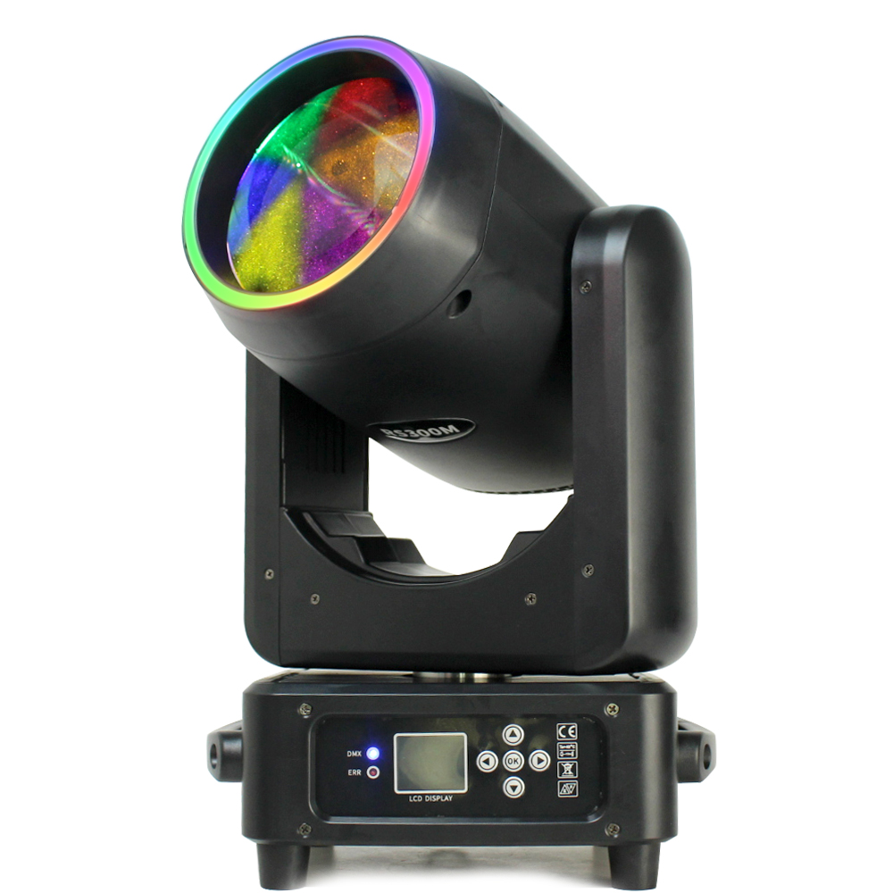

User Manual

1. INTRODUCTION
Thank you for choosing the Acue Lighting Halo Beam 300. In order to use this product correctly and safely, please read the instructions carefully before installing and using this product. This manual contains important installation and operation information. Make sure to strictly follow the instructions when installing and operating this product. Retain this manual in a safe place for future reference.
The Halo Beam 300 uses a new high-temperature resistant metal and plastic body. This product is designed and produced in strict accordance with CE standards, and conforms to the international standard of DMX512 signal protocol. It can be controlled manually from the display or through DMX using the built in 3 pin XLR in/out connectors. This fixture has multiple DMX channel modes to choose from. It is suitable for various types of concerts, theaters, studios, nightclubs, bars and other like environments.

2. Safety Instructions
- Please keep this User Manual for future reference. All users of this fixture must read the user manual thoroughly.
- Unpack and check contents carefully to make sure there is no damage caused by shipping before using the unit.
- Before operating, ensure that the voltage and frequency of power supply match the power requirements of the unit.
- It’s important to properly ground the fixture to avoid electric shock.
- The unit is for indoor use only. Use only in a dry location
- The unit must be installed in a location with adequate ventilation, at least 50cm from adjacent surfaces. Be sure that no ventilation slots are blocked
- Disconnect main power before moving fixture.
- Make sure there are no flammable materials close to the unit while operating, as it is fire hazard.
- Use safety cable when mounting this unit. Don’t handle the unit by taking its arms or head. The fixture may only be moved using the built in handles or by holding from the base.
- Maximum ambient operating temperature is :40˚C. Do not operate if the temperature is higher than this.
- Unit surface temperature may reach up to 85˚C. Do not touch the housing bare-hand during its operation. Turn off the power and allow about 15 minutes for the unit to cool down before replacing or serving.
- In the event of serious operating problem, stop using the unit immediately. Never try to repair the unit by yourself. Repairs carried out by unskilled individuals can lead to further damage or malfunction. Please contact the nearest authorized technical assistance center. Always use the same type Spare parts.

3. Maintenance and Installation

3.1 Maintenance
- To reduce the risk of electrical shock or fire, do not expose this unit to rain or moisture.
- Intermittent usage will extend this fixtures service life.
- Please clear the fan, fan net, and optical lens of any dust or obstructions in order to keep the fixture in a proper work state.
- Do not use alcohol or any other organic solvent to wipe the shell.

3.2 Statement
All fixtures have been tested thoroughly before leaving the factory. In order to keep the product in good condition and ensure safe operation, users should follow the safety precautions and warnings in this manual.

Important: Damages caused by not following the guidance in this user manual are not covered under warranty. The manufacturer is not responsible for product issues caused by misuse.

3.3 Safety Precaution
- In order to guarantee the product’s life expectancy, do not store or use in damp places or environments over 60˚C.
- Always mount this unit in a safe and stable manner. Mounting system must be able to withstand 10x that of the fixture’s weight. A safety cable must always be used as a secondary source for securing the fixture.
- Skilled individuals must only perform the installation of this fixture.
- This product can be used in the voltage range of 90-240V and is an indoor product. Please make sure that the power mains voltage used is not higher/or lower than what the product can withstand! ! The power plug must be inserted into a protected Class I socket and must be grounded properly.
- In order to make sure the product is used properly, please read this manual carefully.

3.4 Cable connection (DMX)
Make sure to use a cable conforming to specifications EIA RS-485: 2-pole twisted, shielded, 120Ohm characteristic impedance, 22-24 AWG, Low capacity. Do not use microphone cable or other cable with characteristics differing from those specified. The end connections must be made using XLR type 3 or 5 pin male/female connectors. A terminating plug must be inserted into the last fixture with a resistance of 120 Ohm (minimum 1/4 W) between terminals 2 and 3.
IMPORTANT: The wires must not make contact with each other or with the metal casing of the connectors. The casing itself must be connected to the ground of the connector plugs.

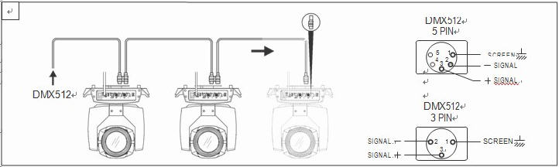

3.5 Rigging (Optional)
This equipment can be positioned and fixed by a clamp in every direction of the stage. The included locking system makes it easy to fasten to the bracket.
Attention! Two clamps are required to mount the equipment. Every clamp is locked to the fixture by the included omega fastener. The Omega fastener can only be locked clockwise.
Attention! A safety cable is also required when hanging the fixture. The safety cables is a secondary source of safety when hanging fixtures.

***BEFORE HANGING FIXTURE***
- Check all rigging clamps for damages. Discard clamp if damaged and replace with a properly functioning clamp. Make sure the hanging point/structure can support ten times the weight of all the equipment, clamps, wiring and other fixtures mounted to it.
- Make sure to tie the screws of the clamp firmly. Use one M12 screw per bracket(Grade 8.8 or higher) to clamp bracket, and then screw on the nuts.
- Level the two hanging points at the bottom of clamp. Insert fastener to the bottom, lock the two levers by 1/4 turn clockwise; then install another clamp.
- Install a safety cable, which can withstand at least ten times the weight of the fixture.
- Make sure pan/tilt lock is unlocked. You must position the fixture at least 3 feet away from flammable materials or lighting source. Low capacity
- The casing itself must be connected to the ground of the connector plugs.
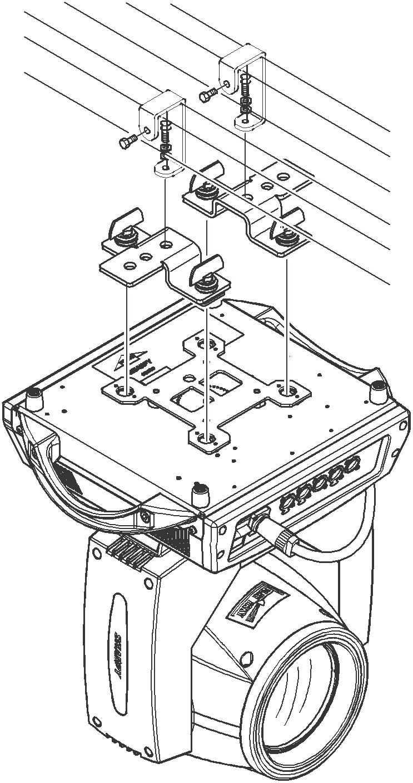
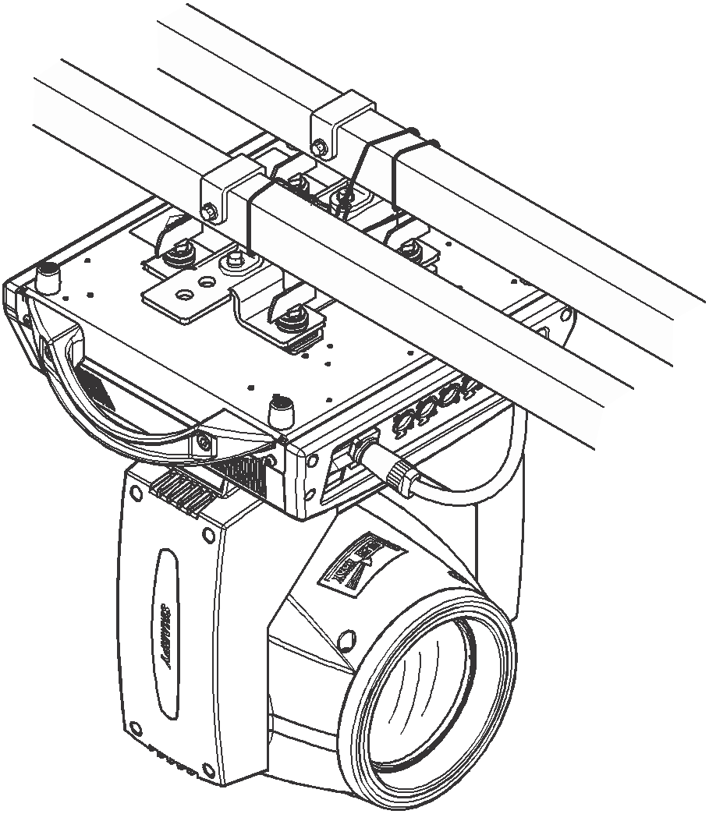

4. Display Operation

4.1 Brief
The display on this fixture is equipped with touch response technology. If you wish not to use the touch screen technology you may use the buttons located on the right of the display.
Note: Be careful to not damage the touch screen display by keeping sharp objects away from the fixture.

4.2 Operation

4.2.1 Operating the light using touch or KEY
- Click item or value with finger to complete operation of set light setting (parameters) or view light state.
- The area on the right hand side is the 4 KEY control pad and is used as an auxiliary input interface. If disabling the touch function, the KEYr can be chosen to set the parameter.

4.2.2 Parameter value setting
When the selected item’s value needs to been modified, the dialog shown in Figure 4 will popup.

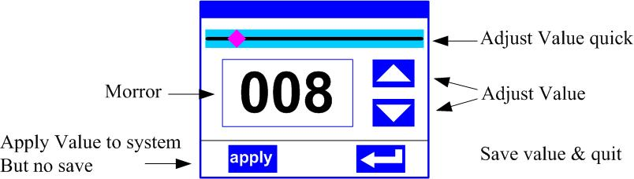
Figure 4 Dialog of DMX value setting
- Modify value：You can quickly modify a value via pulling the slider to the desired position, or clicking the button of ‘up’ or ‘down‘ with your finger on the right side to set the exact desired value.
- Apply value：When wanting to save the new value, press the ‘apply’ button on bottom of screen to apply.
- Save Value: Click on the “OK” button in lower right corner to save into the internal memory.

4.2.3 On/OFF Parameter Settings
- When the selected parameters is a ON or OFF option, you can directly modify the setting by clicking the corresponding option, the setting will been saved immediately.
- When the parameter is a key item, chick corresponding item, a dialog like shown in Figure 5 will pop up and ask for you to confirm. Chick ‘sure’ to confirm.

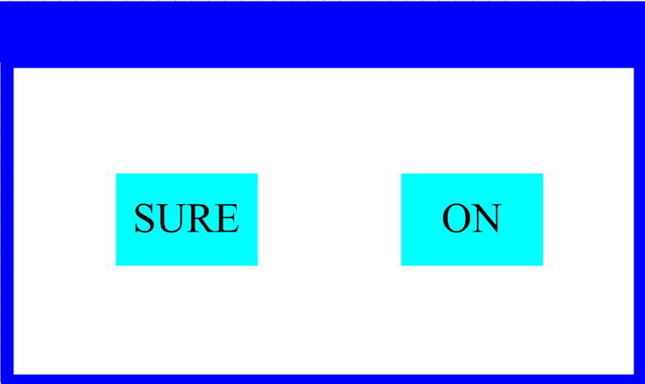
Figure 5 Dialog of confirm

4.2.4 Sub Menu (Parameter)
Click item in the main menu, enter corresponding sub menu, like shown in Figure 6, total 6 sub menus, includes class of parameter and status:
- ADDRESS：Used to set the fixture’s DMX address.
- WORKMOD：Used to select the fixture’s work mode, master or slave mode when in auto run mode.
- DISPLAY：Used to set the display parameters such as language and screen brightness.
- TEST：Used for testing the fixture, modify DMX channel data to test function， the corresponding function of reference channel function table.
- ADVANCED：Used to set the fixture operation parameters.
- STATUS：Used to view the current status of the fixture.

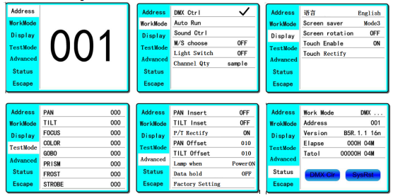
Figure 6 Parameter menu

4.3 Operation and Parameter Menu
- In main menu, click any of the 6 function buttons to enter the corresponding parameter menu.
- In the sub menu (page), click main item on the left side of display to enter corresponding sub menu (page) quickly.

4.3.1 ADDR--> Address: Set DMX Address
Click and select the "ADDR" to enter the page of the DMX address setting. Choose a number in the range of 1 to 512, the address code cannot be greater than 494 (minimum channels required is 18), otherwise the light will not be controlled properly. Following is the operation:
Enter the page to adjust the DMX address, as shown in Figure 7, click the blank area on the right side of display. This will will pop up the dialog as in Fig. 4, modify the value to desired address, then click ‘ENTER’ to confirm and save DMX address.

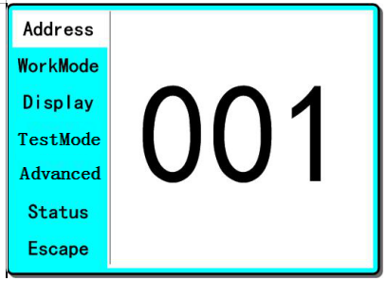
Figure 7 DMX Address Page

4.3.2 MODE--> WorkMode: Set fixture work mode
Enter the page marked ‘WorkMode’ as shown in Figure 8 to modify this setting. Here you can set the fixture work mode, control lamp and alter DMX channel mode.

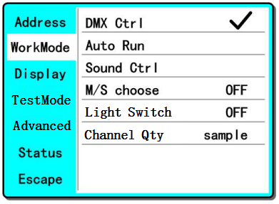
Figure 8 Work Mode Page
◆ DMX Ctrl: Choose to set DMX Mode,
◆ Auto Run: Choose to set Auto Mode,
◆ Sound Ctrl: Choose to set Sound Mode,
◆ M/S Choose: Available only in ‘AUTO RUN’ or ‘SOUND Ctrl’ mode.
ON--> Master. (Data will be sent to other slave fixtures immediately.)
OFF--> Slaver.(Will not send data to other fixtures via DMX Cable).(Default)
◆ Lamp Switch:
ON--> Turn on the light,
OFF--> Turn off the light.
◆ Channel Qty: This Fixture support 1 DMX Channel mode: 18 channel mode。

4.3.3 DISP-->DISPLAY: Set display
This fixture supports 2 languages and has option for display rotation，Enter page as shown in Figure 9 to set parameter following to adjust these settings:

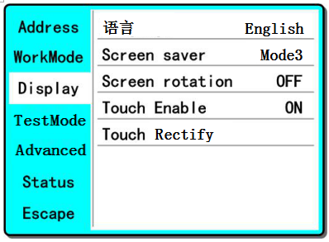
Figure9 Display Edit Page
◆ Language: English / 中文 (Chinese).
◆ Screen Saver: when panel is idle(these is no operation in 10 second), display will enter screen saver status.
OFF--> No screen saver.
Mode1--> Power-saving mode, turn off the display.
Mode2--> Displays the current address.
Mode3--> Displays the icon and the current working mode. (Default)
◆ Screen Rotation: Used to invert display.
ON--> Normal display.(Default)
OFF--> 180° display inversion.
◆ Touch enable：Disable or enable touch function,.
ON--> Enable touch function.(Default)
OFF--> Disable touch function.
◆ Touch adjust：Adjust touch sensitivity.

4.3.4 TEST--> Test Mode
Enter the page as shown in Figure 10, Light will enter into test mode, in this mode, the light will not receive the data from DMX controller.:

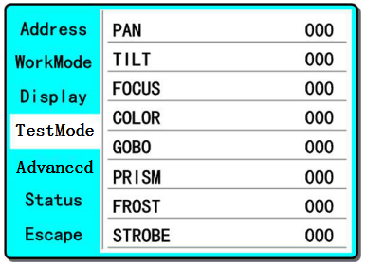
Figure 10 Fixture Test Page

◆ PAN: range of 0 to 255;
◆ TILT: range of 0 to 255;
◆ FOCUS: range of 0 to 255;
◆ COLOR: range of 0 to 255;
◆ GOBO: range of 0 to 255;
◆ PRISM: range of 0 to 255;
◆ FROST: range of 0 to 255;；
◆ STROBE: range of 0 to 255;

2.3.5 ADVA-->Advanced: Set light run parameter
Enter the page as shown in Figure 10, set the parameter of light:

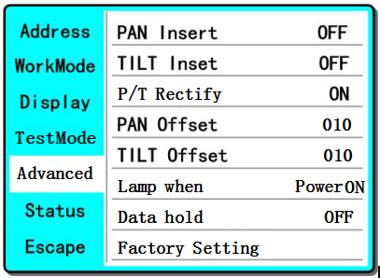
Figure 11 Run Parameter Page

◆ Pan Invert: Reverse PAN movement
OFF--> Pan Normal move. (Default)
ON--> Reverse PAN move.
◆ Tilt Invert: Reverse TILT movement
OFF--> Tilt Normal move. (Default)
ON--> Reverse Tilt move.
◆ P/T Rectify: Disable or enable position rectify function.
OFF--> Disable P/T rectify
ON--> Enable P/T rectify-(Default)
◆ Pan Offset: Set PAN original position. Default: 10
◆ Tilt Offset: Set TILT original position. Default: 10
◆ Lamp when:
PowerON--> Turn on the lamp when power on.(Default)
RstDone--> Turn on the lamp after reset.
Manual--> Manually turn on the lamp.
◆ Data hold:
OFF--> When no DMX signal, return to middle position.(Default)
ON--> When no DMX signal, stop in the final position.
◆ Factory Setting: Restore all parameters to factory setting.

4.3.6 STAT-->Status: View status
Enter the page as shown in Figure 12:

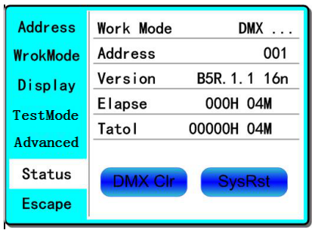
Figure 12 Fixture Status Page
◆ Work Mode: Show the current working mode.
◆ Address: Show the current address.
◆ Version: Show the version of the fixture software.
◆ Elapse: Working hours after turn on.
◆ Total: Cumulative hours of operation
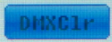
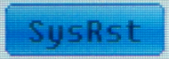
When <Data hold> set <ON>,click to clear DMX data, and make the lamp return to themiddle position.
Click to reset.

CHANNEL | NAME | VALUE | Function
CH1 | PAN | 0-255 | 0-540˚
CH2 | TILT | 0-255 | 0-270˚
CH3 | PAN Fine | 0-255
CH4 | TILT Fine | 0-255
CH5 | XY speed | 0-255 | Fast to slow
CH6 | Rainbow Filter | 0-127 | None
CH6 | Rainbow Filter | 128-255 | Insert Rainbow color filter
CH7 | STROBE | 0-3 | Dark
CH7 | STROBE | 4-99 | Slow strobe to fast strobe
CH7 | STROBE | 100-199 | Slow strobe to fast strobe (mode 2)
CH7 | STROBE | 200-249 | Slow strobe to fast rand strobe
CH7 | STROBE | 250-255 | White
CH8 | DIMMER | 0-255 | 0-100%
CH9 | COLOR | 0-4 | White
CH9 | COLOR | 5-9 | White + Color1
CH9 | COLOR | 10-14 | Color1
CH9 | COLOR | 15-19 | Color1 + Color2
CH9 | COLOR | 20-24 | Color2
CH9 | COLOR | 25-29 | Color2 + Color3
CH9 | COLOR | 30-34 | Color3
CH9 | COLOR | 35-39 | Color3 + Color4
CH9 | COLOR | 40-44 | Color4
CH9 | COLOR | 45-49 | Color4 + Color5
CH9 | COLOR | 50-54 | Color5
CH9 | COLOR | 55-59 | Color5 + Color6
CH9 | COLOR | 60-64 | Color6
CH9 | COLOR | 65-69 | Color6 + Color7
CH9 | COLOR | 70-74 | Color7
CH9 | COLOR | 75-79 | Color7 + Color8
CH9 | COLOR | 80-84 | Color8
CH9 | COLOR | 85-89 | Color8 + Color9
CH9 | COLOR | 90-94 | Color9
CH9 | COLOR | 95-99 | Color9 + Color10
CH9 | COLOR | 100-104 | Color10
CH9 | COLOR | 105-109 | Color10 + Color11
CH9 | COLOR | 110-114 | Color11
CH9 | COLOR | 115-119 | Color11 + Color12
CH9 | COLOR | 120-124 | Color12
CH9 | COLOR | 125-129 | Color12 + Color13
CH9 | COLOR | 130-134 | Color13
CH9 | COLOR | 135-139 | Color13+ Color14
CH9 | COLOR | 140-144 | Color14
CH9 | COLOR | 145-149 | Color14 + White
CH9 | COLOR | 150-2032 | Rotate Clockwise (fast to slow)
CH9 | COLOR | 203-255 | Rotate Anti-Clockwise (slow to fast)
CH10 | GOBO | 0-4 | White
CH10 | GOBO | 5-9 | Gobo1
CH10 | GOBO | 10-14 | Gobo2
CH10 | GOBO | 15-19 | Gobo3
CH10 | GOBO | 20-24 | Gobo4
CH10 | GOBO | 25-29 | Gobo5
CH10 | GOBO | 30-34 | Gobo6
CH10 | GOBO | 35-39 | Gobo7
CH10 | GOBO | 40-44 | Gobo8
CH10 | GOBO | 45-49 | Gobo9
CH10 | GOBO | 50-54 | Gobo10
CH10 | GOBO | 55-59 | Gobo11
CH10 | GOBO | 60-64 | Gobo12
CH10 | GOBO | 65-69 | Gobo13
CH10 | GOBO | 70-128 | Rotate Clockwise (fast to slow)
CH10 | GOBO | 129-131 | Stop
CH10 | GOBO | 132-190 | Rotate Anti-Clockwise (slow to fast)
CH10 | GOBO | 191-195 | Shake slow to fast GOBO1
CH10 | GOBO | 196-200 | Shake slow to fast GOBO2
CH10 | GOBO | 201-205 | Shake slow to fast GOBO3
CH10 | GOBO | 206-210 | Shake slow to fast GOBO4
CH10 | GOBO | 211-215 | Shake slow to fast GOBO5
CH10 | GOBO | 216-220 | Shake slow to fast GOBO6
CH10 | GOBO | 221-225 | Shake slow to fast GOBO7
CH10 | GOBO | 226-230 | Shake slow to fast GOBO8
CH10 | GOBO | 231-235 | Shake slow to fast GOBO9
CH10 | GOBO | 236-240 | Shake slow to fast GOBO10
CH10 | GOBO | 241-245 | Shake slow to fast GOBO11
CH10 | GOBO | 246-250 | Shake slow to fast GOBO12
CH10 | GOBO | 251-255 | Shake slow to fast GOBO13
CH11 | PRISM1 | 0-127 | OFF
CH11 | PRISM1 | 128-255 | Insert prism1
CH12 | PRISM2 | 0-127 | OFF
CH12 | PRISM2 | 128-255 | Insert prism 2
CH13 | PRISM ROT | 0-127 | 0˚-400˚ (indexing)
CH13 | PRISM ROT | 128-190 | Rotate forward (fast to slow)
CH13 | PRISM ROT | 191-192 | Stop
CH13 | PRISM ROT | 193-255 | Rotate reverse (slow to fast)
CH14 | FROST | 0-127 | None
CH14 | FROST | 128-255 | Insert frost
CH15 | FOCUS | 0-255 | Focus adjust
CH16 | RESET | 240-255 | Reset (Hold over 3 seconds to reset)
CH17 | LED HALO | 0-255 | Multiple halo control options
CH18 | LED HALO SPEED | 0-255 | Speed for Halo functions

5. Technical Specifications:
- Input Voltage: AC110V-240V, 50/60Hz
- Max Power Draw: 300W
- Light source: 1X150W White LED
- LED RING: 48pcsX0.2W RGB 3IN1 LEDs
- Color Wheel: 10 colors + open
- Gobo Wheel: 18 gobos + open
- Prism: 2 indexing and rotating prism options
- Channels: 18 CH
- Operation: DMX512, Sound, Auto, Master-slave
- Dimmer: 0~100% linear dimmer
- Pan Move: 540°
- Tilt Move: 270°
- Lens Angle: 1.6 °
- Color temperature: 7500K LED
- Life: 50000 hours, low power consumption, energy saving and environmental protection
- Product size: 33*21*48cm
- Net weight: 13.5KG

For more information about this product as well as other products please visit www.AcueExpress.com
Or contact us directly:
Email: Info@AcueLighting.com
Phone: (818) 646-7526/ (818) 672-6822

